Exam 2 ECE5410

1. (exam1.nb, exam1_h.m)
2. The transfer function is simplified in Mathematica

H(z) = Y(z) / U(z) = 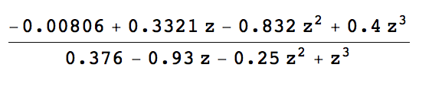

1. (c) Poles and zeros are

Poles = {{z -> -1.02}, {z -> 0.45}, {z -> 0.82}}

Zeros = {{z -> 0.02}, {z -> 0.50}, {z -> 1.55}}

1. Controlability matrix is 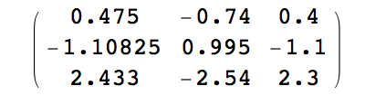

Eigenvalue of Ctrl is {3.9562, -0.168574, -0.0176275}. The magnitude of the first one is more than 200 times as the third one.

1. Observability matrix is 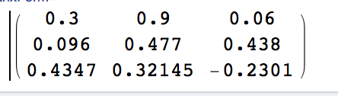

The magnitude of eigenvalue is {0.961523, 0.331218, 0.331218}, all smaller than 1.

1. It is minimal. The orders of denominator and numerator of transfer function are all 3, which matches the size of the matrix A. Also, the Det[ctrl] = 0.011756, Det[obsr] = 0.105484, the system is controllable and observable.
2. It is not strict causal, as the order of denominator equals to the order of numerator.
3. Matlab rootlucus() is used to find the g. (exam1_h.m)

We can select

gain =

13.0490

poles =

1.3009

0.4882

-0.1023

to make the transfer function unstable. Below are the rootlocus and step response of Y/R, showing that it is unstable.

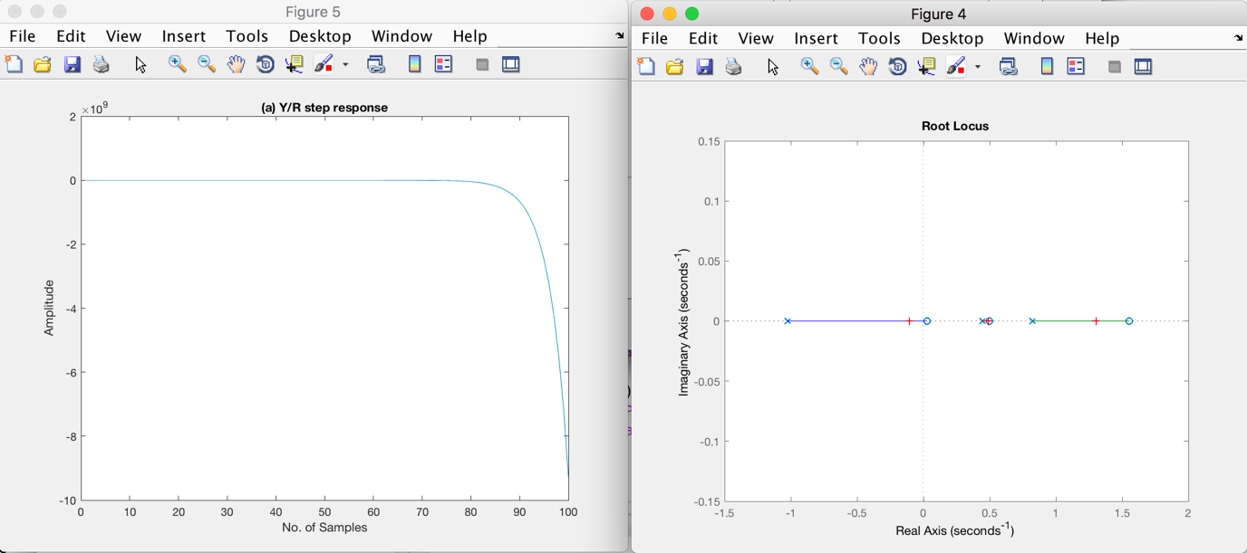

1. Select

gain =

0.6042

poles =

-0.8083

0.8700

0.4532

The rootlocus and step response below show that the system is stable.

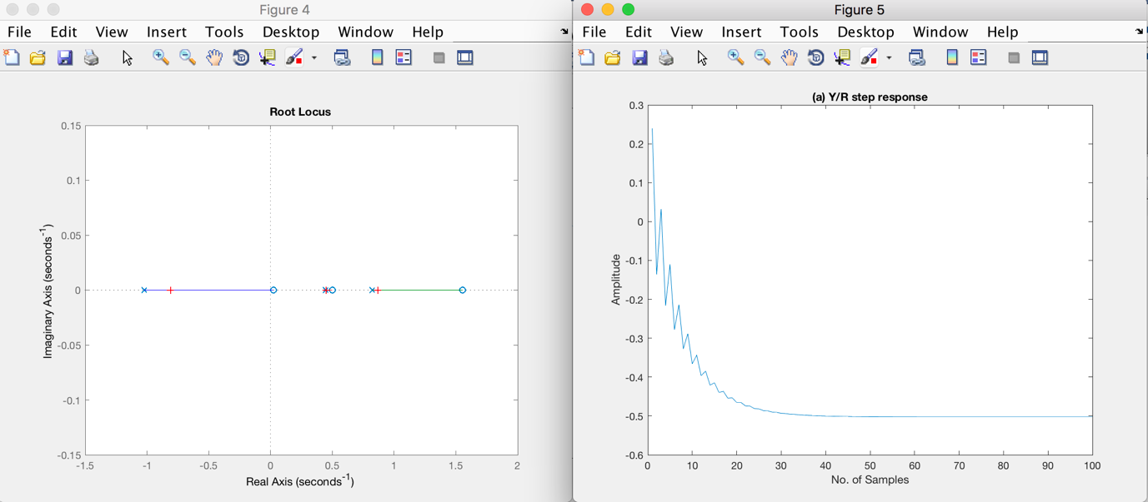

(j)Making close-loops poles complex-valued is impossible as the root locus is on the real axis.

1. (a)

0.3760 < r < 0.7218

Using place() in Matlab, place the poles on

dp=[0.6 + 0.15 * ii, 0.6 - 0.15 * ii, 0.2, 0.3];

Then we can find k

k =

2.1800 -3.2429 2.8811 5.5640

The final value of y is 0.5439 and the max of y is 0.5823, meaning that the present overshoot is 7% .

In y, the 9th is the last one that exceeds 2% range of the final value. Therefore the settling time is 9 samples. The step response is shown below.

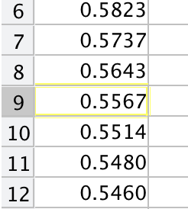

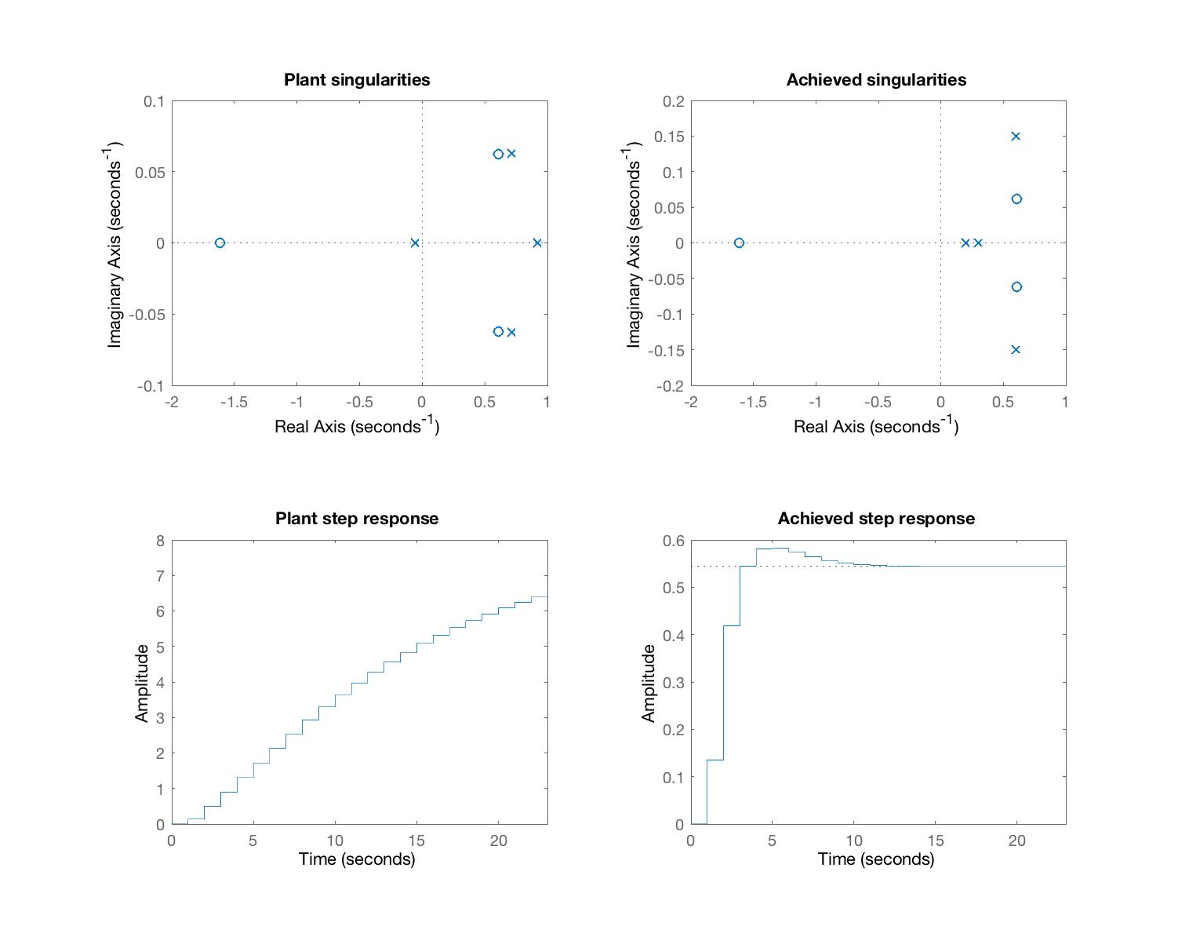

(b) exam2_b.m

Select the eigenvalues of (A – lc) as [0.5 0.3 0.1 0.05], use place to compute the l as

l =

1.2133

0.0213

-0.1482

0.2620

Then plot the xerrorT.xerror. The max of the error is below 6 and it decays to below 0.01 at t = 6.

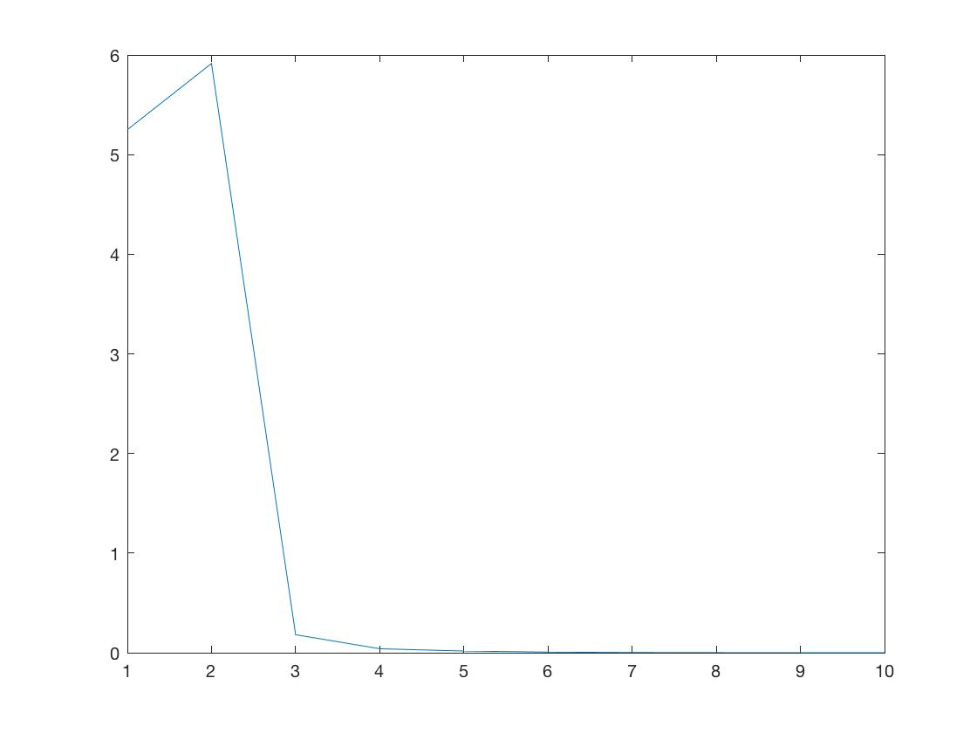

1. (a) Use Matlab dfsp to simulate. (exam3_a.m)

PN(z) = F(z) = MD(z) = N(z) = Poly(cancelled poles)

= 1z^4 + 0.67z^3+0.1037z^2 - 0.006595 z - 0.0015675

PD(z) = G(z) = 1.0000z^4 + 3.1000z^3 + 5.6873z^2 + 4.7993z+ 1.3123 (vector g)

MN(z) = M(z) = 1.0733z^3 -1.8021z^2 + 1.0819z - 0.2347 (vector m)

(b) Use dstep() to plot the step response

The maximum of step response and stable value of response is

ymax =

19.0250

x =

7

final =

18.0887

Therefore, the percent overshoot is 5.17%. The time of the first peak is t = 7

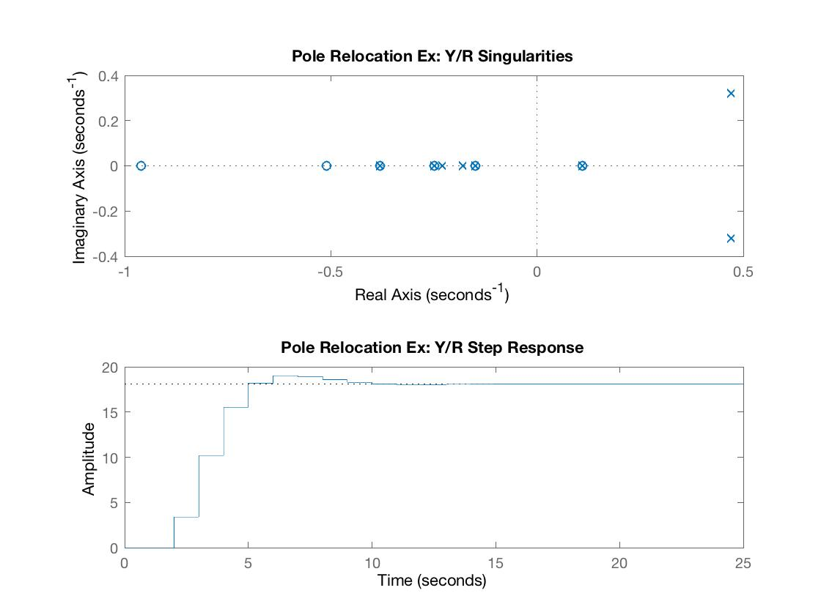

(c) Plot the step response of U/R. The maximum value of u is 1.43.

maxu =

1.4300

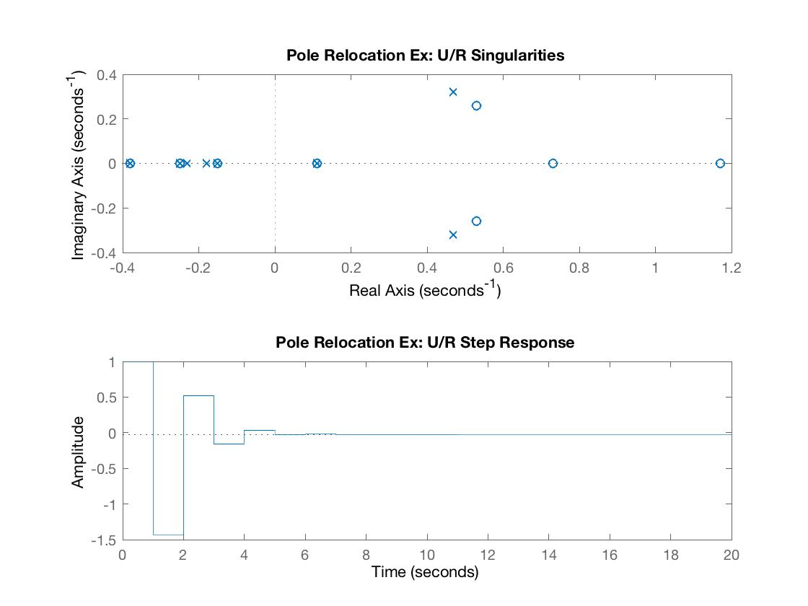

1. (a)

Use place command to compute the k and l

k = place(A,b,dcp)

l = place(A',c',dop)'

We can get

k =

-0.1576 0.2028 -0.2244 0.2577

l =

-4.3121

0.4636

14.6663

-6.0470

(b)

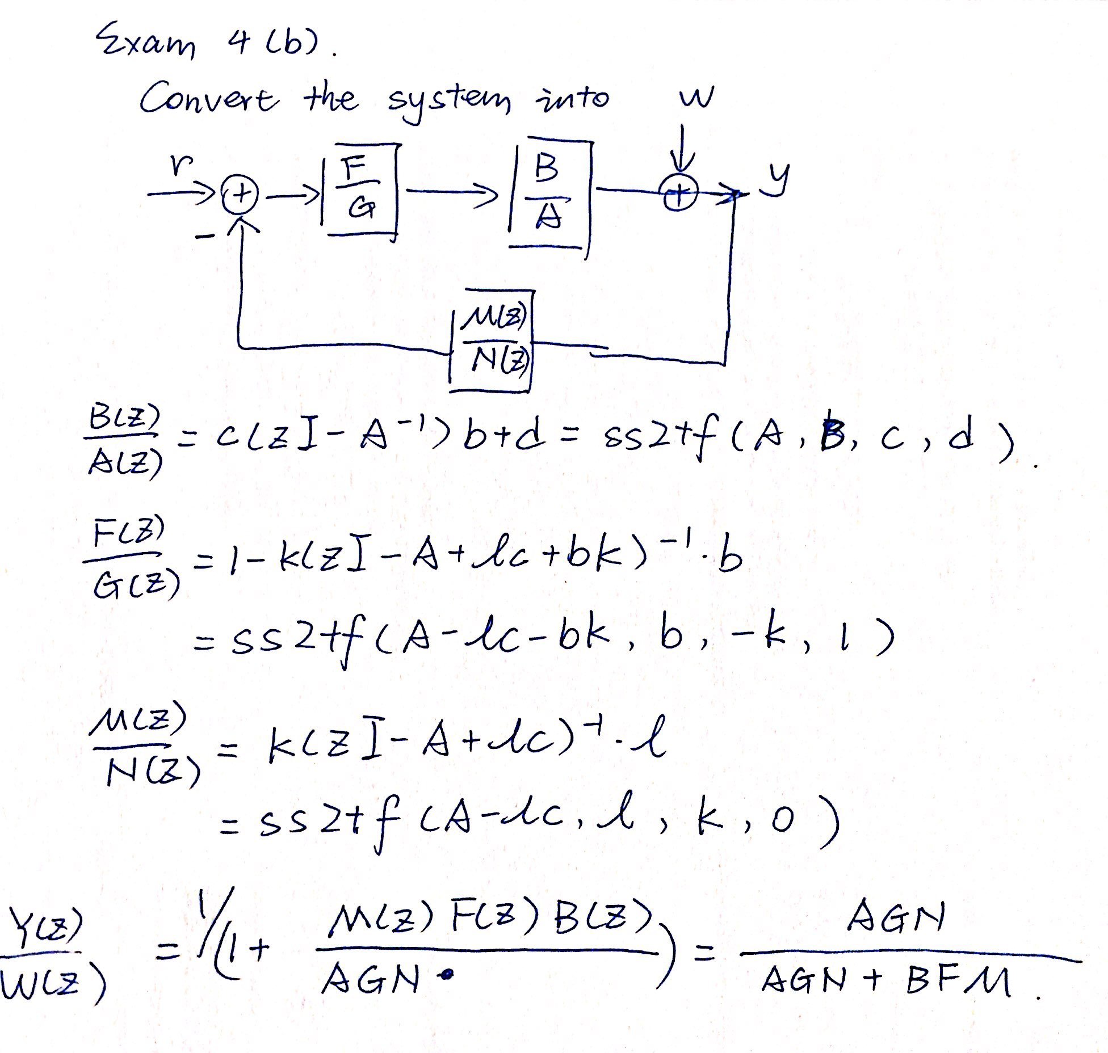

Use ss2tf() in Matlab to compute B, A, F, G, M and N. Then we can use convolution to compute Y/W,

Yz =

Columns 1 through 9

-1.0000 0.1000 4.3750 -1.9471 -3.6367 1.2423 0.9702 -0.1941 -0.0986

Columns 10 through 13

0.0058 0.0025 -0.0001 -0.0000

Wz =

Columns 1 through 9

1.0000 -0.1000 -0.7075 0.1060 0.3252 0.0616 -0.0341 -0.0144 -0.0011

Columns 10 through 13

0.0003 0.0001 0.0000 0.0000

**Y/W =**



Poles and zeros are

|  |  |
| --- | --- |
| Poles | Zeros |
| 0.7000 + 0.4000i  0.7000 - 0.4000i  0.4000 + 0.0000i  0.2000 + 0.0000i  -0.4000 + 0.0000i  -0.4000 + 0.0000i  -0.3000 + 0.0000i  -0.3000 + 0.0000i  -0.1500 + 0.0000i  -0.1500 + 0.0000i  -0.1000 + 0.0000i  -0.1000 + 0.0000i | -2.0410  1.2820  1.2767  -0.7159  0.5000  0.4930  -0.4000  -0.3000  -0.1500  0.1303  0.1249  -0.1000 |

Pzmap is shown as

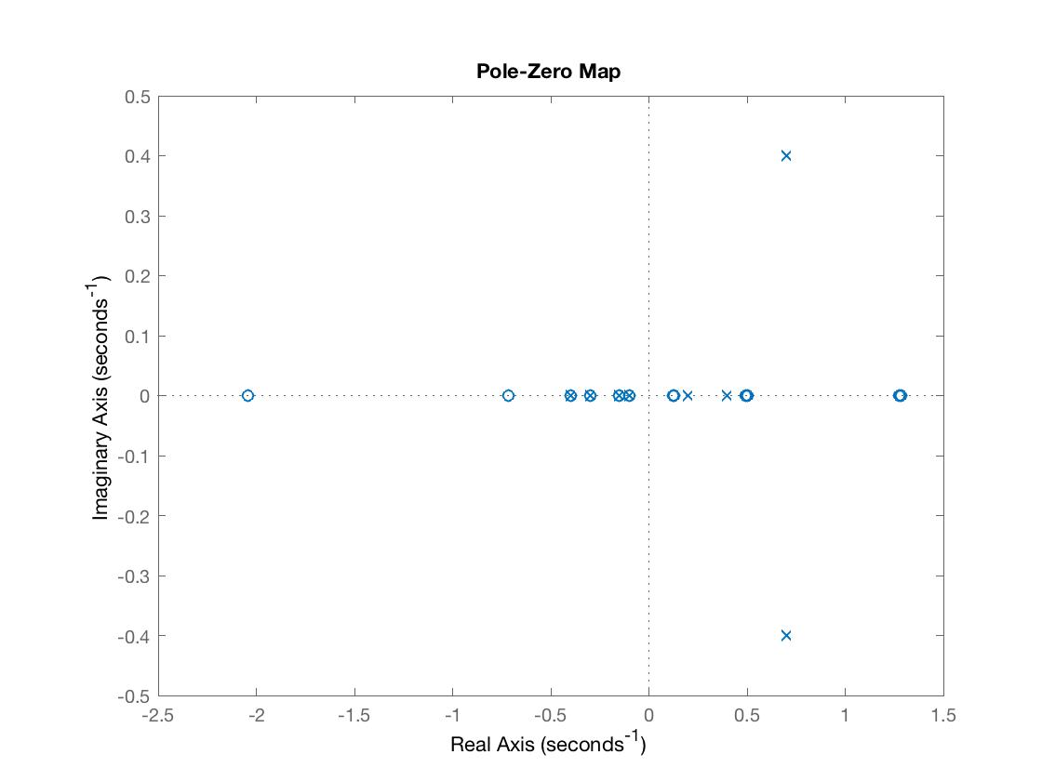

1. (a) exam5_a.m

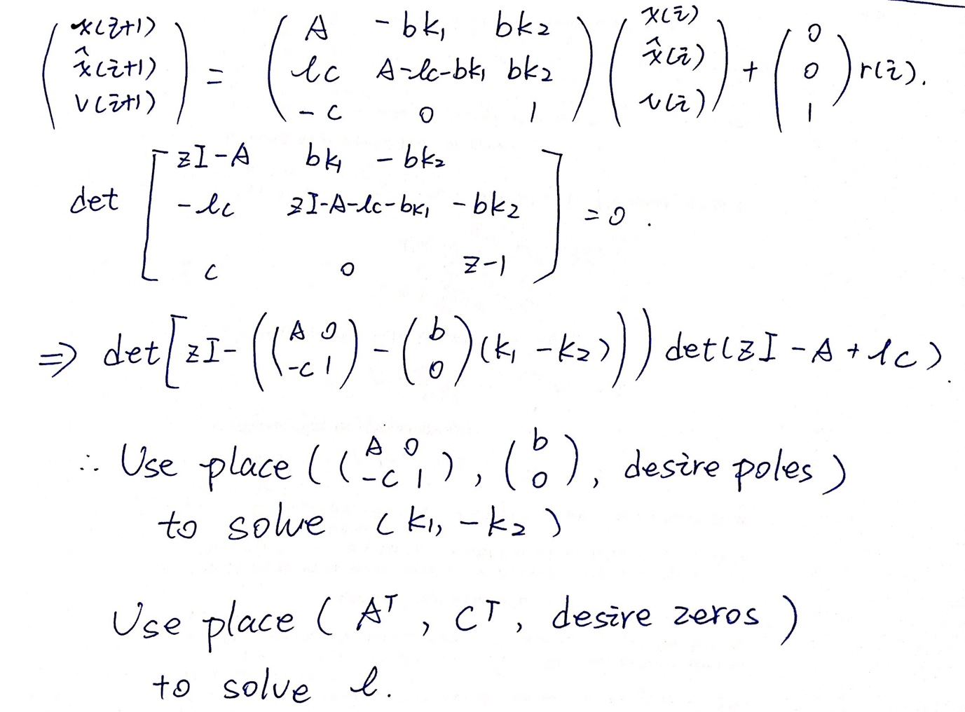

Then we can get

k1 =

1.1483 -2.9402 -2.2663 0.0845

k2 =

2.1786

l =

25.2465

-1.4439

0.5156

-2.0969

Then we can plot the step response. We can see it has unity DC gain. Poles and zeros desired are shown in pzmap.

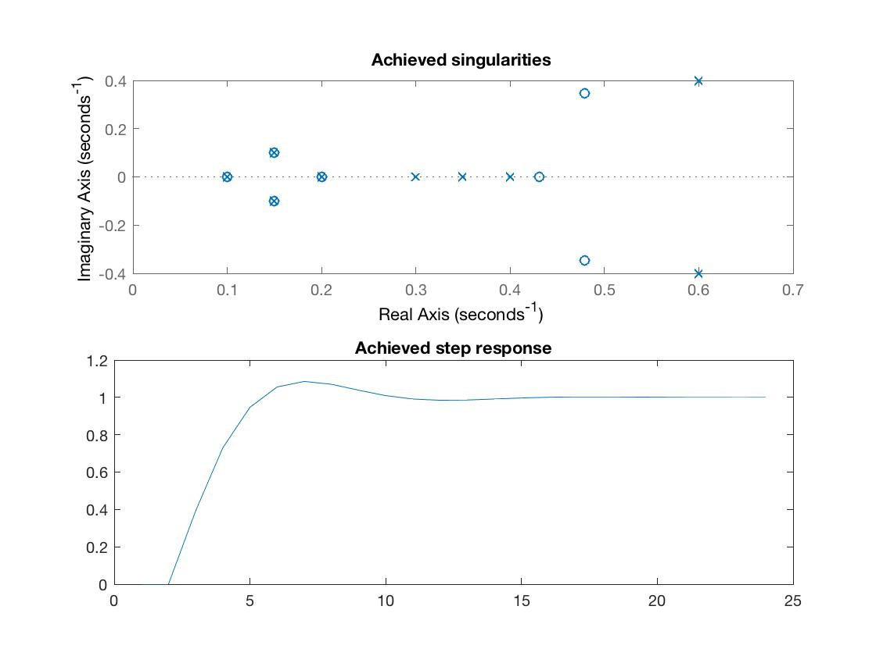

(b) Use the same k1,k2 and l to compute the step response of the system with bbar.

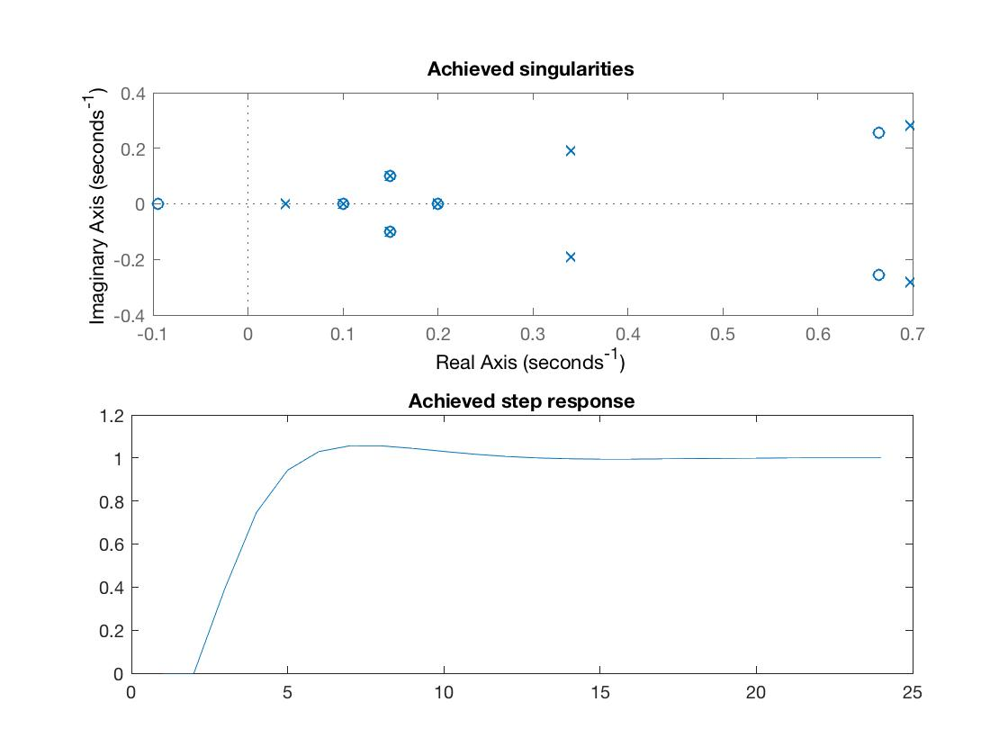

The maximum of output y is 1.0567, and the final value of y is 1, meaning that the present overshoot is 5.67%, DC gain is 1.

maxy =

1.0567

y(10) is the last one exceeds 2% of the final value, so the settling time is 11 samples.

